**University of Petroleum and Energy Studies**

School of Computer Science

Department of Cybernetics



**Graphics & Animation Tools**

**LAB FILE**

**(Session: 2020-2021)**

Course: B. Tech with Specialization in Open Source and Open Standards

Batch: 2017-2021

Semester: VIIth

**Submitted By: -**

Ananya Raghav

Roll No: R100217008

SAP ID: 500062570

**Submitted To: -**

Dr. Durgansh Sharma Assistant Professor

Department of Cybernetics

**Experiment– 2**

**Aim-** Design a LOGO/ Picture using GIMP

**Steps followed-**

1. Draw the LOGO/Picture which you want to use and save it in your computer.
2. Open GIMP.
3. Select File 🡪 new file 🡪 and choose a size screen with white background.
4. Now, again open File 🡪 Open as Layers 🡪 Select the image you want to use.

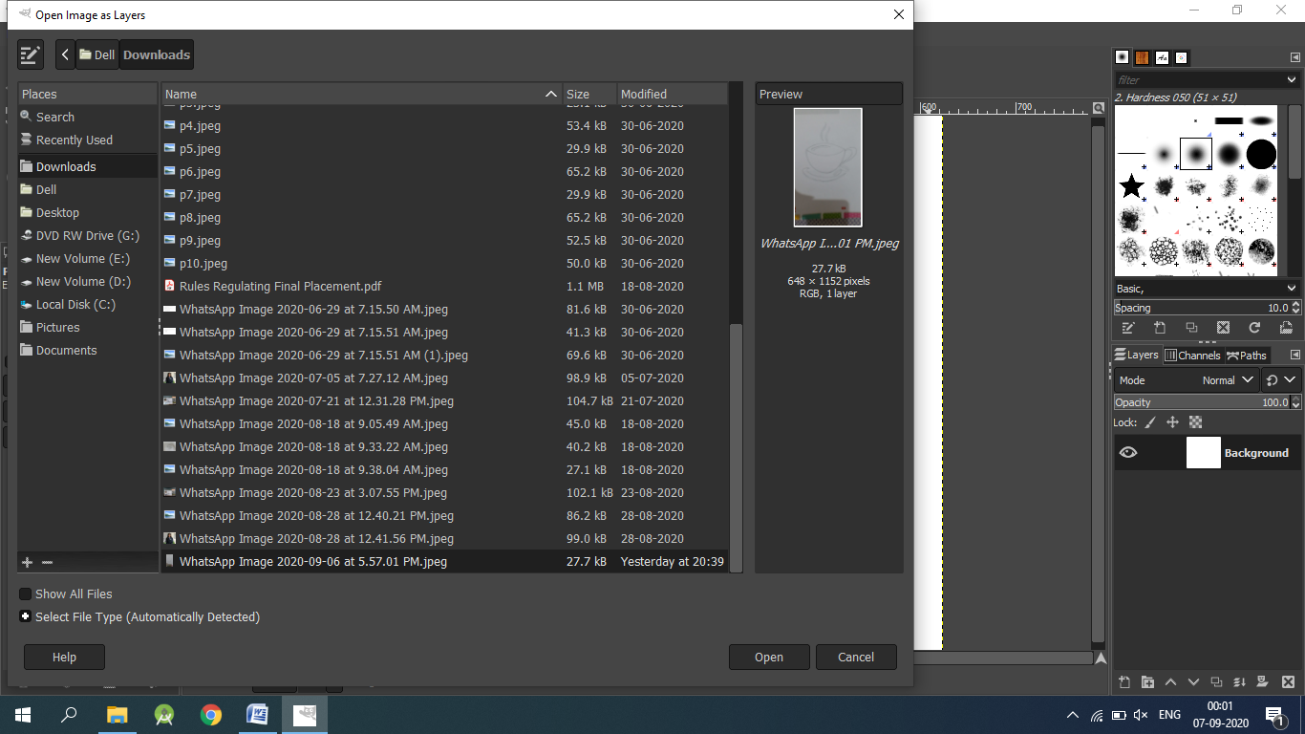

1. After the image appears, select Free select tool and start selecting the regions which you want to keep by making borders around that picture.

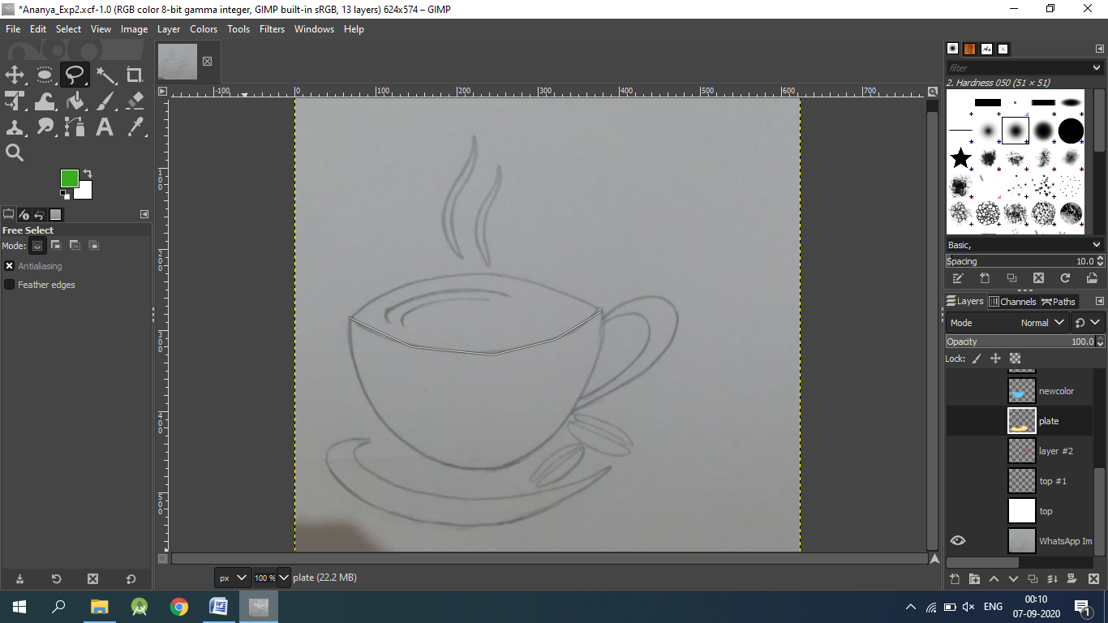

1. After selecting the region, right click 🡪 Select 🡪 From path.

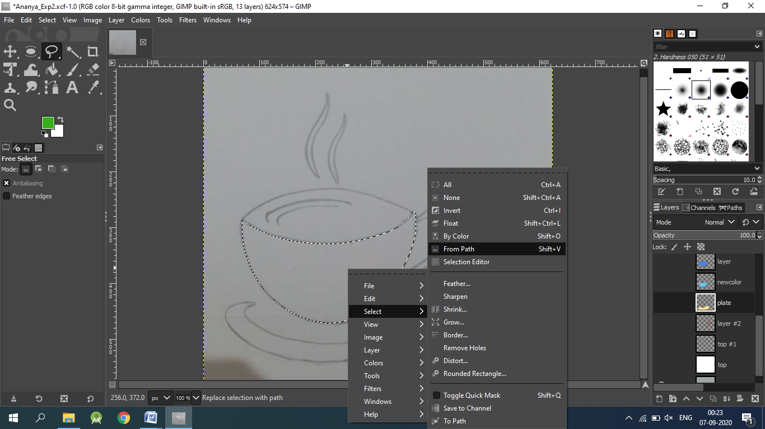

1. Now create a new layer by clicking the small icon at bottom right and, name the layer accordingly.
2. Similarly repeat this process until all the regions required are there in the form of layer.
3. Now, to make the image look more interesting, fill the colour by selecting the colour of your choice. Use the bucket fill tool for this.
4. After colouring the output will look something like this.

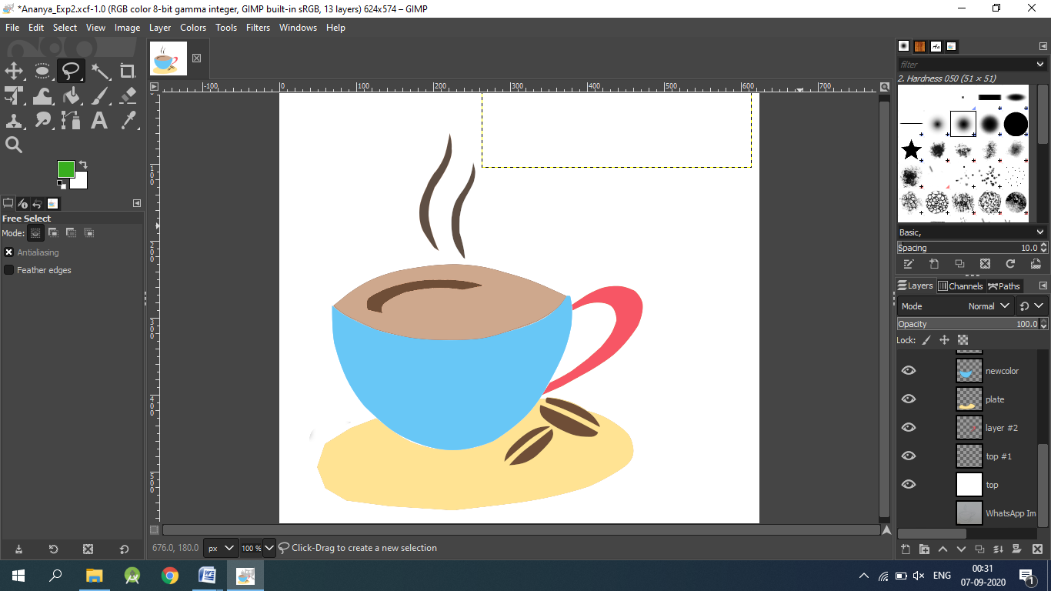

11. To add text, select the Text tool from the toolbar, write the text and choose the font colour of your choice.

12. Once everything is done save the file by going to File 🡪 Export As 🡪 Export.

Image Used-

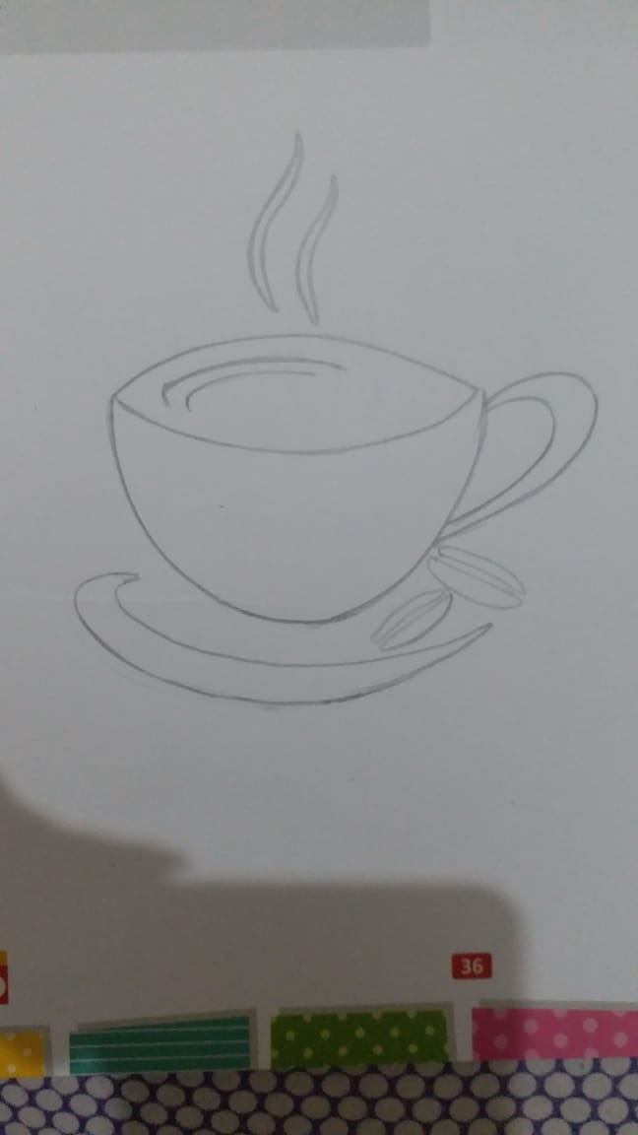

Output-

